DAMAN INVESTMENTS
INTERNATIONAL PAIRS
2015-16 QUALIFYING SERIES
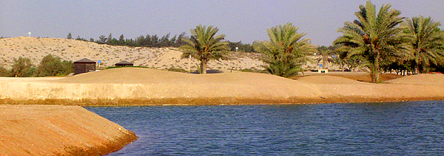

AL GHAZAL GOLF CLUB – 30th October 2015
PAIRS BETTERBALL STABLEFORD ¾ HANDICAP INDEX
1:30pm Shot Gun Start

Hotel Denia Marriott La Sella Golf Resort & Spa in Spain - venue for the 2015 World Final
TEAM ENTRY DETAILS

PLAYER 1
NAME............................................................Email...............................................Mobile No......................................................HCP Index......................................

PLAYER 2
NAME............................................................Email...............................................Mobile No......................................................HCP Index......................................

CONTACT DETAILS:
Name: Rory Young
Email: m&t@adac.ae
Phone: 02 575 8040
ENTRY FEE/PAYMENT OPTIONS:
Members AED 200
EGF Members AED 300

The 2015-16 International Pairs UAE Qualifying Series is proudly presented by

