DAMAN INVESTMENTS
INTERNATIONAL PAIRS
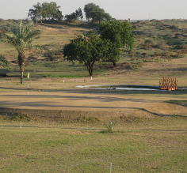
2015-16 QUALIFYING SERIES

SHARJAH WANDERERS GOLF CLUB – 13th NOVEMBER 2015
PAIRS BETTERBALL STABLEFORD – ¾ HANDICAP INDEX
8:30am Shot Gun Start

Hotel Denia Marriott La Sella Golf Resort & Spa in Spain - venue for the 2015 World Final
TEAM ENTRY DETAILS

PLAYER 1
NAME............................................................Email...............................................Mobile No......................................................HCP Index......................................

PLAYER 2
NAME............................................................Email...............................................Mobile No......................................................HCP Index......................................

CONTACT DETAILS:
Email: radriver@gmail.com
Phone: 050 6524764
Name: Bob Driver
ENTRY FEE/PAYMENT OPTIONS:
Members AED 100
EGF Members AED 200

The 2015-16 International Pairs UAE Qualifying Series is proudly presented by OnCourse Golf

