DAMAN INVESTMENTS
INTERNATIONAL PAIRS
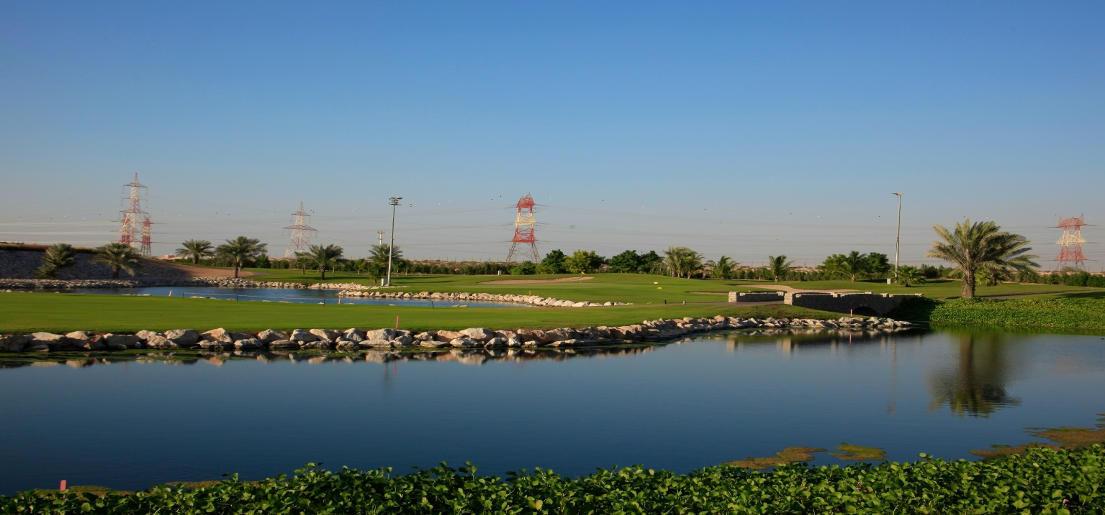
2015-16 QUALIFYING SERIES

SHARJAH GOLF & SHOOTING CLUB –14th JANUARY 2016
PAIRS BETTERBALL STABLEFORD – 3/4 HANDICAP INDEX
4pm Shot Gun Start & Rate includes Presentation Dinner after play

Hotel Denia Marriott La Sella Golf Resort & Spa in Spain - venue for the 2015 World Final
TEAM ENTRY DETAILS

PLAYER 1
NAME............................................................Email...............................................Mobile No......................................................HCP Index......................................

PLAYER 2
NAME............................................................Email...............................................Mobile No......................................................HCP Index......................................

CONTACT DETAILS:
Email:golfres@golfandshootingshj.com
Phone: 06-5487777
Name: Golf Reservation Staff
ENTRY FEE/PAYMENT OPTIONS: Golf Members AED 135
Country Members AED 265
Loyalty Pass Members AED 365
EGF Members AED 455

The 2015-16 International Pairs UAE Qualifying Series is proudly presented by OnCourse Golf

